EXPERIMENT – 11

Performing IP Spoofing Using a GitHub Tool in Kali Linux

Aim
To demonstrate IP spoofing techniques using an open-source GitHub tool in Kali Linux for understanding network-level attack concepts and security vulnerabilities.

Software Requirements
- Host Operating System: Windows / Linux / macOS
- Virtualization Software: Oracle VirtualBox
- Guest Operating System: Kali Linux
- Tool Source: GitHub (IP Spoofing Tool – Educational Use)
- Programming Language: Python / Bash (as per tool)
- System Requirements:
  - RAM: Minimum 4 GB (8 GB recommended)
  - Disk Space: Minimum 30 GB
  - Processor: Intel/AMD with Virtualization support

Introduction
IP spoofing is a technique where an attacker forges the source IP address in network packets to impersonate another system. It is commonly used in attacks such as DDoS, session hijacking, and bypassing IP-based authentication. This experiment demonstrates IP spoofing using a publicly available GitHub tool to understand how attackers manipulate packet headers. Kali Linux provides a safe and controlled environment for ethical network security experimentation.

Procedure

Step 1: Start Kali Linux Virtual Machine
- Open Oracle VirtualBox.
- Start Kali Linux.
- Log in using Kali credentials.

Step 2: Open Terminal
- Launch Terminal in Kali Linux.
- Update system packages:
- sudo apt update

Step 3: Clone IP Spoofing Tool from GitHub
- Clone the repository:
git clone https://github.com/FDX100/Auto_Tor_IP_changer.git
- Navigate to the tool directory: cd Auto_Tor_IP_changer

Step 4: Install Dependencies
- Install required dependencies:
- sudo apt install python3

Step 5: Configure the Tool
- Open the Terminal:
- Open Root mode
- Run python3 install.py

Step 6: Execute IP Spoofing
- Run the tool with root privileges:
- python3 autoTOR.py
- Enter the No. of time and how many times IP Change in Seconds.
- Monitor IP-Changes in the terminal

Output
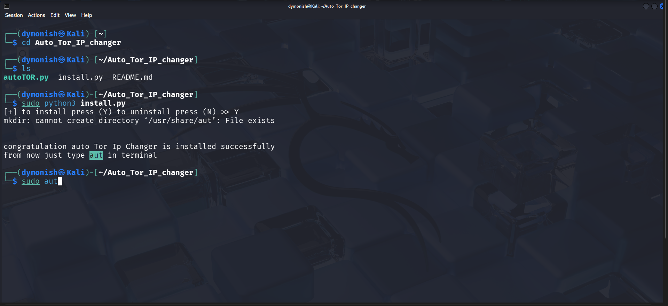

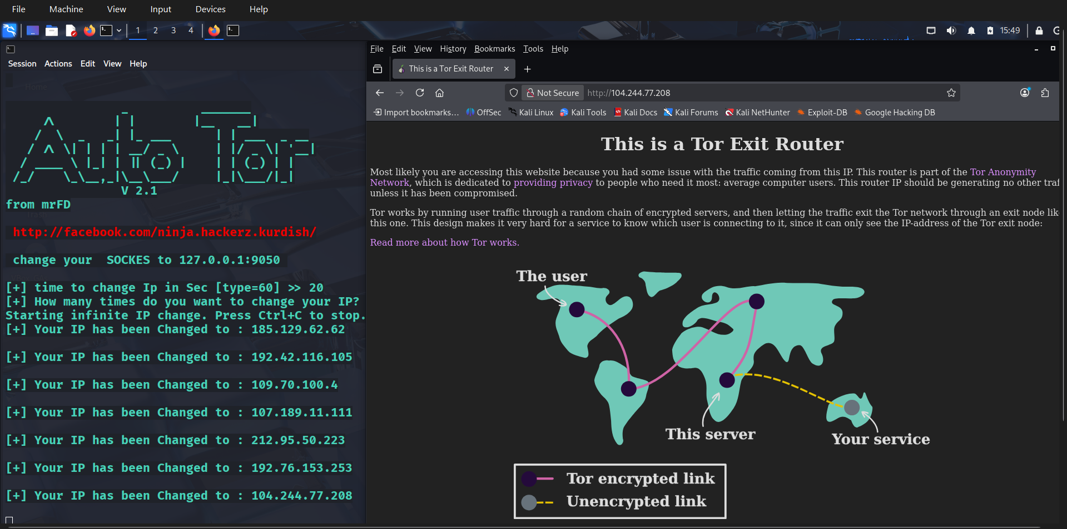

Result
IP spoofing was successfully demonstrated using a GitHub-based tool in Kali Linux.
The experiment illustrates how attackers can manipulate IP headers and highlights the need for robust network security mechanisms.

